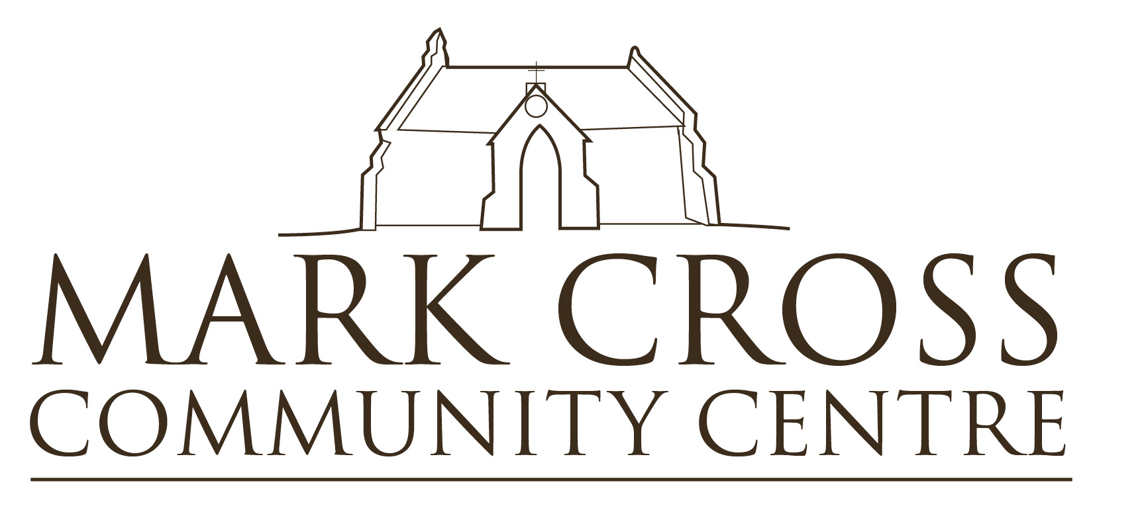
Mark Cross Community Centre, St Mark’s Church, Mark Cross, East Sussex TN6 3PJ
Registered Charity No.1171983

Supplementary hire agreement October 2020
COVID-19
I understand that our existing hire agreement remains valid and this forms a supplement to that hire agreement.
I confirm I have submitted our new Covid secure risk assessment and insurance details and agree to adhere to the following as part of the hire agreement: -
- To provide evidence of public liability insurance with a £2m limit of liability and an updated Covid secure risk assessment.

- To bring hand sanitiser to bookings which will aid as a back up to the MCCC supplied dispensers.

- Face shields or face coverings will be worn unless the activity is covered under an exception.

- To set up a cleaning station during sessions. All touch points must be wiped clean with anti-bacterial wipes or anti-bacterial spray and cloth provided by me.

- All rubbish will be taken away.

- The toilets will be cleaned after use. This means the toilet seats, lids, taps and door handles.

- Upon leaving, the door handles, key and key box will be cleaned.

- A one-way system will be implemented during my bookings – entrance into the building through the front door and exit through the back fire door for all attendees at my classes.

- I will record all names and contacts details for the track and trace system and keep this information for 21 days and notify MCCC immediately in respect of any positive test results.

- I am aware of school peak times of 8.30-9pm/1-1.30pm/3-3.30pm and will avoid attendees of my classes waiting outside the front or back doors of MCCC at these times.

- I understand that I must act within the law and adhere to any advice specific to my activity from a national governing body.

If you have a new continuous cough, high temperature or a loss/change of sense of smell or taste, you and or your clients must stay home and follow government guidelines: https://www.gov.uk/coronavirus-covid-19-list-of-guidance

